
Department of Computer Science and Engineering
A/2, Jahurul Islam Avenue, Jahurul Islam City, Aftabnagar, Dhaka-1212

Summer 2025 Semester

Predict the age of abalone from physical measurements
- Comparative Analysis of Abalone and Crab Age Prediction

Course Code : CSE 303
Course Title : Statistics for Data Science
Section : 2

Submitted To:
Dr. Mohammad Manzurul Islam
Assistant Professor
Department of Computer Science & Engineering

Submitted By:
- 2021-3-60-101 Md Maruf Hasan
- 2021-3-60-172 Abdul Muhaimin Ibne Ali
- 2022-1-60-381 Chinmoy Karmakar

Index
Sl. No. | Section Title | Page No.
1 | Introduction | 2
2 | Dataset Description | 2
2.1 | Abalone Dataset (UCI) | 2
2.2 | Crab Age Prediction Dataset (Kaggle) | 3
3 | Data Preprocessing | 3
3.1 | Missing Value Analysis and Treatment | 3
3.2 | Duplicate Entry Handling | 4
3.3 | Categorical Variable Conversion | 4
3.4 | Outlier Detection and Analysis | 4
4 | Exploratory Data Analysis (EDA) | 4
4.1 | Correlation Analysis | 4
4.2 | Target Variable Distribution | 5
4.3 | Feature Distribution Analysis | 5
4.4 | Visualizations | 5
5 | Machine Learning Models | 9
5.1 | Data Preparation for Machine Learning | 9
5.2 | Linear Regression Implementation | 9
5.3 | Logistic Regression Implementation | 11
5.4 | Support Vector Regression (Additional Analysis) | 14
6 | Results and Comparison | 16
6.1 | Cross-Dataset Performance Analysis | 16
6.2 | Feature Importance Insights | 18
6.3 | Biological Interpretation | 18
7 | Conclusion | 18
 | Key Achievements | 18
 | Research Findings | 18
 | Model Performance Summary | 18
 | Biological Implications | 19
 | Research Contributions | 19
 | Future Directions | 19
 | Limitations | 19
 | Final Remarks | 19

Introduction
This project undertakes a comprehensive comparative analysis of two marine creature datasets: the Abalone dataset from the UCI Machine Learning Repository and the Crab Age Prediction dataset from Kaggle. The primary objective is to explore, preprocess, and build machine learning models to predict the age of abalones and crabs based on their physical characteristics. By analyzing these two similar yet distinct datasets, we aim to identify common patterns, differences in data characteristics, and compare the performance of various machine learning models on each dataset.
The significance of this study lies in understanding the factors influencing age prediction in marine species and evaluating the effectiveness of different modeling approaches. Age prediction in marine biology is crucial for population studies, conservation efforts, and understanding ecosystem dynamics. Marine biologists often rely on physical measurements to estimate age, as direct age determination can be invasive or destructive to the organisms.
Our analysis employs multiple machine learning approaches including Linear Regression for continuous age prediction and Logistic Regression for binary age classification (young vs old). This dual approach provides insights into both precise age estimation and categorical age grouping, which are valuable for different research applications. The insights gained will contribute to understanding the biological relationships between physical characteristics and age in these marine species.

Dataset Description
Both datasets share a remarkably similar structure, each containing 9 columns with analogous features representing physical measurements and demographic information.

Abalone Dataset (UCI)

Source: https://archive.ics.uci.edu/dataset/1/abalone

Basic Information:
- Shape: (4,177 rows, 9 columns)
- Source: UCI Machine Learning Repository
- Data Types: 7 float64, 1 int64, 1 object
- Target Variable: Rings (age indicator)

Feature Description:
- Sex: Categorical variable (M=Male, F=Female, I=Infant)
- Length: Longest shell measurement in mm (continuous)
- Diameter: Shell diameter perpendicular to length in mm (continuous)
- Height: Shell height with meat in shell in mm (continuous)
- Whole Weight: Weight of whole abalone in grams (continuous)
- Shucked Weight: Weight of meat in grams (continuous)
- Viscera Weight: Gut weight after bleeding in grams (continuous)
- Shell Weight: Weight of shell after being dried in grams (continuous)
- Rings: Number of rings in shell (target variable: rings + 1.5 = age in years)

Crab Age Prediction Dataset (Kaggle)

Source: https://www.kaggle.com/datasets/sidhus/crab-age-prediction

Basic Information:
- Shape: (3,893 rows, 9 columns)
- Source: Kaggle
- Data Types: 7 float64, 1 int64, 1 object
- Target Variable: Age (direct age measurement)

Feature Description:
- Sex: Categorical variable (F=Female, M=Male, I=Infant)
- Length: Shell length measurement in mm (continuous)
- Diameter: Shell diameter measurement in mm (continuous)
- Height: Shell height measurement in mm (continuous)
- Weight: Total weight of crab in grams (continuous)
- Shucked Weight: Weight of meat in grams (continuous)
- Viscera Weight: Internal organ weight in grams (continuous)
- Shell Weight: Shell weight after processing in grams (continuous)
- Age: Direct age measurement in years (target variable)
Both datasets contain a balanced mix of numerical and categorical features, with target variables representing age measurements. The column names and their biological meanings are largely analogous between the two datasets, facilitating meaningful comparative analysis.

Data Preprocessing
The preprocessing phase involved systematic cleaning and preparation of both datasets to ensure optimal performance for machine learning algorithms.

Missing Value Analysis and Treatment

Detection Methodology:
- Utilized df.isnull().sum() to identify missing values in each column
- Calculated missing value percentages using df.isnull().mean() * 100
- Employed the missingno library for visual representation of missing data patterns

Results:
- Abalone Dataset: No missing values detected across all features
- Crab Dataset: No missing values detected across all features
Both datasets demonstrated excellent data quality with complete records, eliminating the need for missing value imputation strategies. This characteristic significantly simplified the preprocessing pipeline and ensured robust model training.

Duplicate Entry Handling

Detection Process:
- Applied df.duplicated().sum() to identify duplicate rows
- Verified data integrity through row-by-row comparison

Results:
- Abalone Dataset: No duplicate entries found
- Crab Dataset: No duplicate entries found
The absence of duplicate entries in both datasets confirmed high data collection standards and eliminated potential bias in model training.

Categorical Variable Conversion
Categorical variables required conversion to numerical format for machine learning compatibility.

Abalone Dataset Encoding:
- Sex variable mapping: {'M': 0, 'F': 1, 'I': 2}
- Created new column 'Sex_Numeric' containing encoded values
- Verified encoding accuracy through value count comparison

Crab Dataset Encoding:
- Sex variable mapping: {'F': 0, 'M': 1, 'I': 2}
- Applied consistent encoding methodology
- Validated conversion through categorical distribution analysis

Outlier Detection and Analysis
Methodology: Implemented Interquartile Range (IQR) method for outlier identification:
- Q1 = 25th percentile
- Q3 = 75th percentile
- IQR = Q3 - Q1
- Lower bound = Q1 - 1.5 × IQR
- Upper bound = Q3 + 1.5 × IQR
Results: Outliers were identified in various numerical features but retained for analysis as they represent natural biological variation rather than data collection errors.

Exploratory Data Analysis (EDA)

Correlation Analysis
Abalone Dataset Correlation Matrix: The correlation heatmap revealed several key insights:
- Strong positive correlations (0.7-0.9) between physical measurements (Length, Diameter, Height)
- High intercorrelations (0.8-0.9) among weight measurements (Whole Weight, Shucked Weight, Viscera Weight, Shell Weight)
- Moderate positive correlation (0.63) between Shell Weight and Rings (age)
- Negative correlation (-0.2 to -0.3) between Sex_Numeric and most physical features, indicating size differences across sex categories
Dataset Correlation Matrix: Similar correlation patterns emerged:
- Strong correlations among morphological measurements
- High weight measurement intercorrelations
- Moderate correlation (0.63) between Shell Weight and Age
- Sex-based correlation differences reflecting biological dimorphism

Target Variable Distribution

Age Distribution Analysis:
- Abalone: Rings distribution showed right-skewed pattern with most individuals having 8-12 rings
- Crab: Age distribution displayed similar right-skewed characteristics with concentration in younger age groups
- Both distributions exhibited natural biological aging patterns with fewer older individuals

Feature Distribution Analysis

Sex Distribution:
- Pie charts revealed balanced representation across sex categories in both datasets
- Infant proportions were smaller compared to adult categories
- Distribution patterns reflected natural population demographics

Physical Measurement Distributions:
- Histograms with Kernel Density Estimation (KDE) showed normal to slightly skewed distributions
- Weight measurements displayed right-skewed patterns typical of biological data
- Size measurements showed more symmetric distributions

Visualizations

1. CORRELATION ANALYSIS: ABALONE :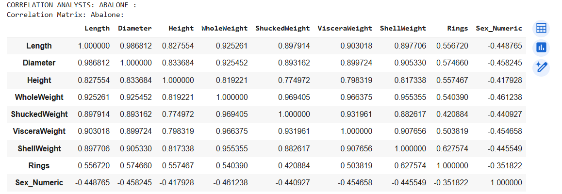

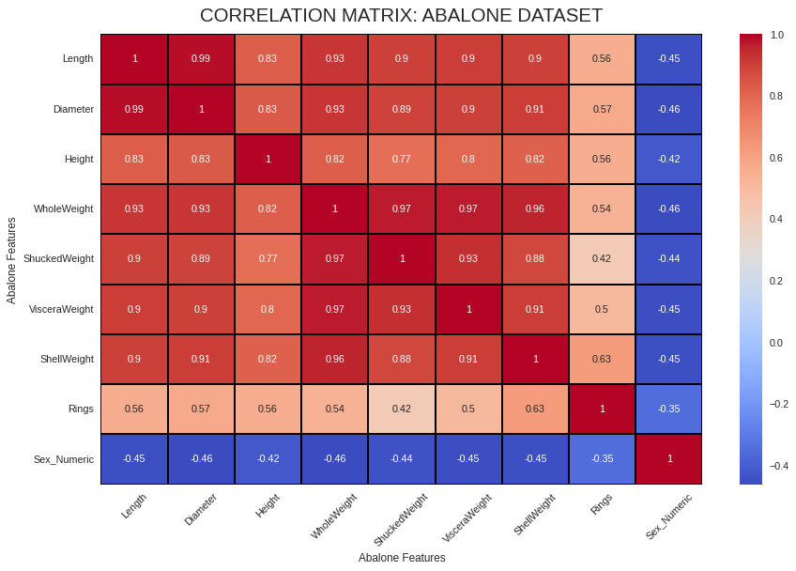

Interpretation: This heatmap shows the correlation matrix for the numerical features in the Abalone dataset. Darker red indicates strong positive correlation, and darker blue indicates strong negative correlation. We can observe strong positive correlations among most physical measurements (Length, Diameter, etc.) and moderate positive correlation between these features and 'Rings' (Age).

2. CORRELATION ANALYSIS: CRAB :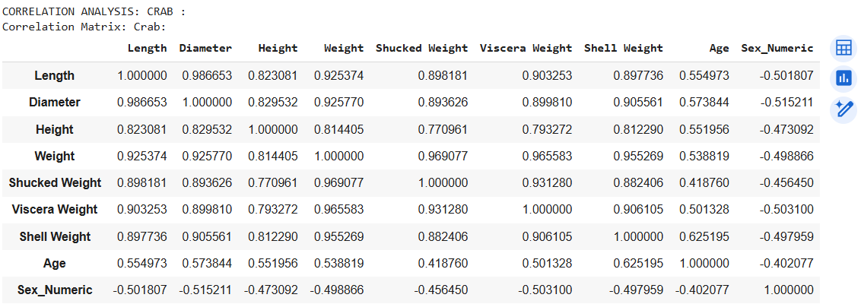

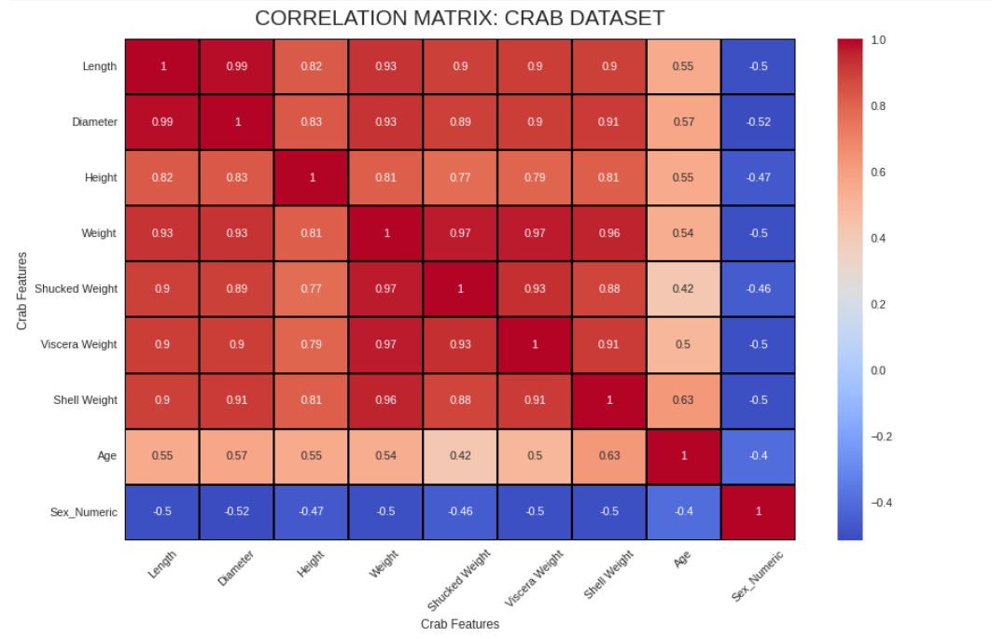

Interpretation: This heatmap shows the correlation matrix for the numerical features in the Crab dataset. Similar to the Abalone dataset, there are strong positive correlations among the physical and weight measurements. 'Shell Weight' shows the highest positive correlation with 'Age'.

3. DATA VISUALIZATION: ABALONE:

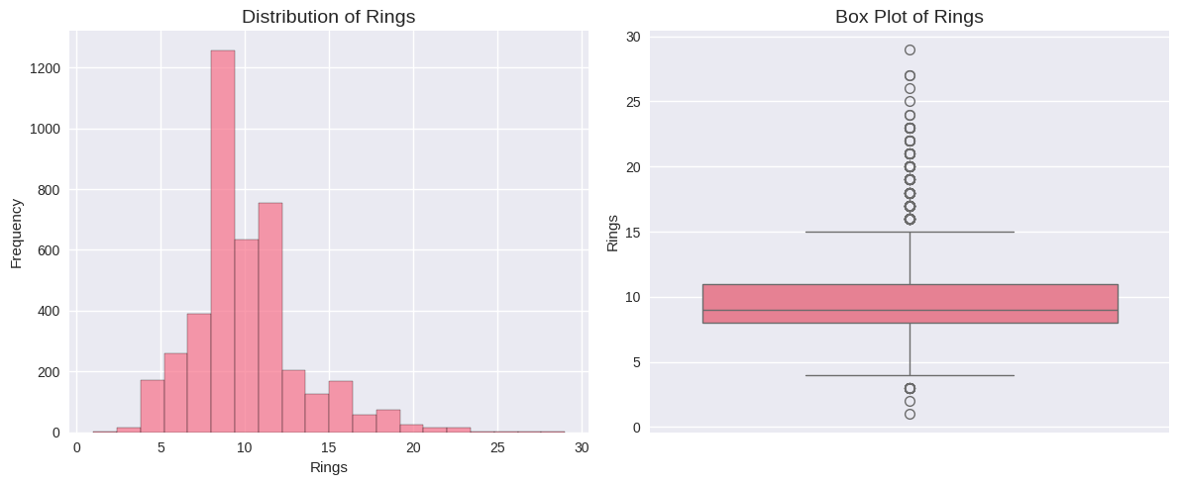
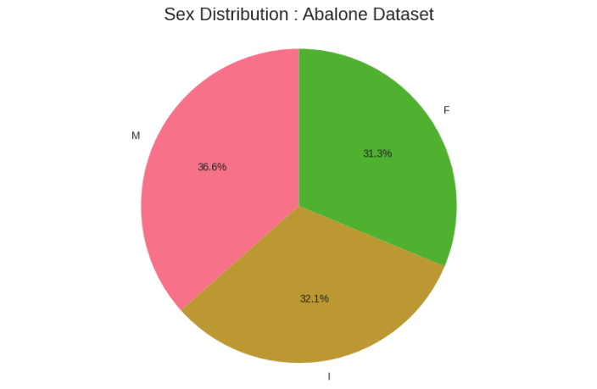
Interpretation: These plots show the distribution of 'Rings' (Age) in the Abalone dataset. The histogram indicates that the majority of abalones in this dataset are younger, with the distribution skewed towards lower ring counts. The box plot shows the median age and highlights the presence of outliers with a higher number of rings.

5. Scatter plot - Abalone Length vs Rings

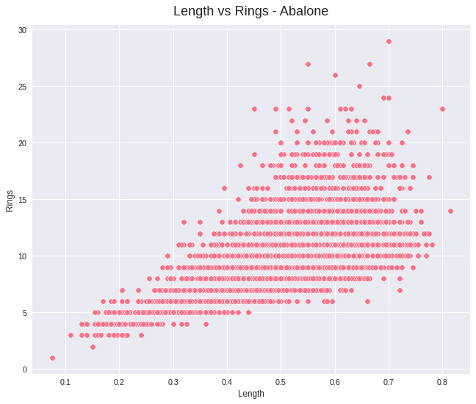
Interpretation: Scatter plot - Abalone Length vs Rings
This scatter plot shows the relationship between 'Length' and 'Rings' (Age) in the Abalone dataset. We can observe a general positive trend, indicating that as the length of the abalone increases, the number of rings (and thus age) also tends to increase. However, the points are quite scattered, especially for higher lengths/ages, suggesting that length alone is not a perfect predictor of age and there is variability in age for abalones of the same length.

6. Distribution of numerical features

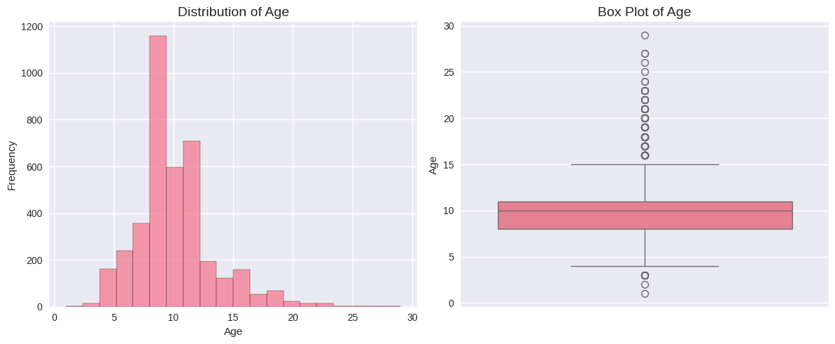

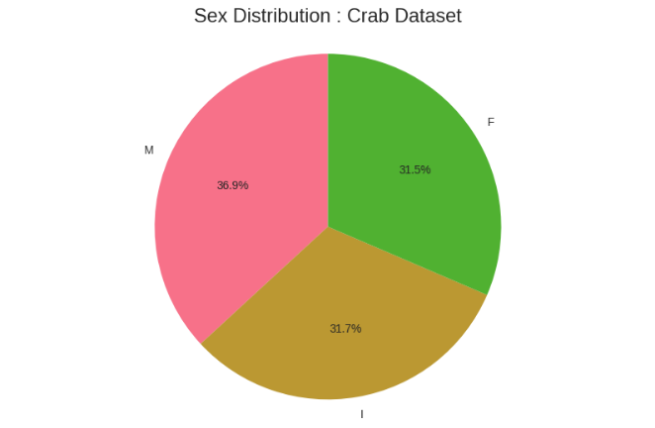 Interpretation: These plots show the distribution of 'Age' in the Crab dataset. Similar to the Abalone dataset, the age distribution is skewed towards younger crabs, with fewer older individuals. The box plot also reveals outliers in the higher age ranges.

7. Scatter plot - Crab Length vs Age

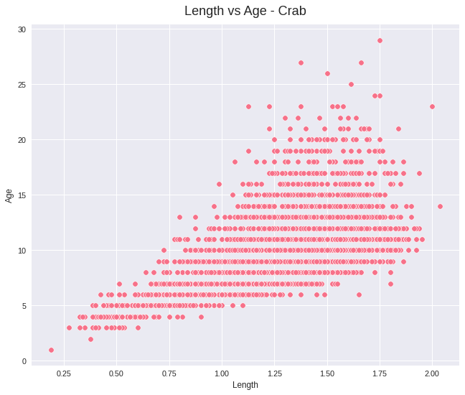
Interpretation: Scatter plot - Crab Length vs Age
This scatter plot visualizes the relationship between 'Length' and 'Age' in the Crab dataset. Similar to the Abalone dataset, there is a clear positive correlation between length and age. As the length of the crab increases, its age generally increases as well. The spread of the data points also suggests that length is a good indicator but not a sole determinant of age, with variations in age occurring among crabs of similar lengths.

Machine Learning Models

Data Preparation for Machine Learning

Feature Engineering:
- Numerical features standardized using StandardScaler for consistent scaling
- Categorical variables encoded as described in preprocessing
- Target variables prepared for both regression and classification tasks

Train-Test Split:
- 80% training data, 20% testing data
- Random state = 42 for reproducible results
- Stratified sampling considered for classification tasks

Linear Regression Implementation
Linear Regression was applied for continuous age prediction using all available numerical features.

Abalone Linear Regression Results:
- Mean Absolute Error (MAE): 1.6068 years
- Mean Squared Error (MSE): 4.9503
- Root Mean Squared Error (RMSE): 2.2249 years
- R² Score: 0.5427 (54.27% variance explained)

Crab Linear Regression Results:
- Mean Absolute Error (MAE): 1.5186 years
- Mean Squared Error (MSE): 4.6487
- Root Mean Squared Error (RMSE): 2.1561 years
- R² Score: 0.5162 (51.62% variance explained)
Performance Analysis: The Linear Regression models demonstrated similar performance across both datasets, with R² scores indicating that approximately half of the age variance can be explained by physical measurements. The RMSE values suggest prediction errors of approximately 2.1-2.2 years on average, which is reasonable considering the biological complexity of age determination.

Linear Regression Results (Abalone)
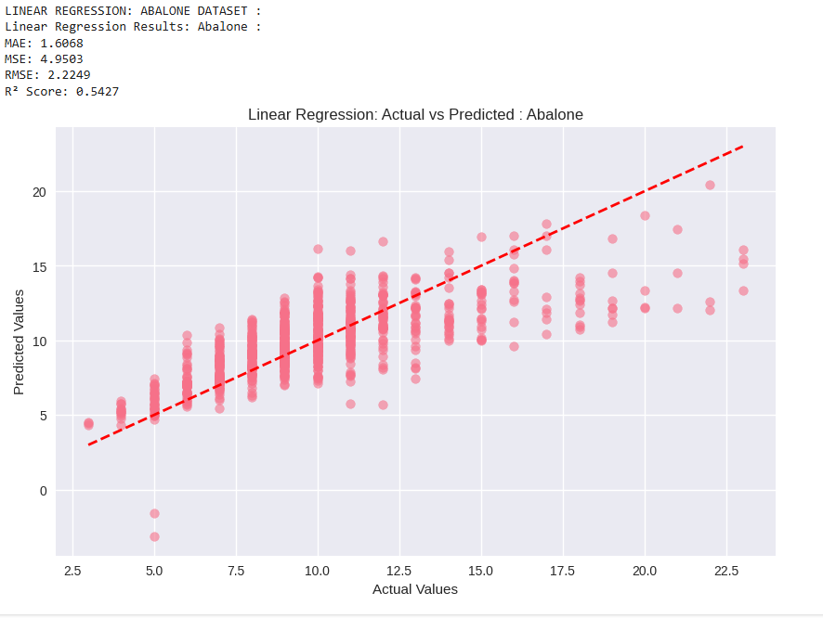

Interpretation of Linear Regression Results (Abalone):

MAE (Mean Absolute Error): This metric represents the average absolute difference between the actual 'Rings' values and the predicted 'Rings' values. An MAE of 1.6068 means that, on average, our Linear Regression model's predictions for abalone rings are off by about 1.61 rings.

MSE (Mean Squared Error): This metric calculates the average of the squared differences between actual and predicted values. It penalizes larger errors more heavily than MAE. An MSE of 4.9503 means the average squared error is about 4.95.

RMSE (Root Mean Squared Error): This is the square root of the MSE and is on the same scale as the target variable ('Rings'). An RMSE of 2.2249 means that the typical error in our predictions is around 2.22 rings.

R² Score: This metric indicates the proportion of the variance in the target variable ('Rings') that is predictable from the features. An R² score of 0.5427 means that approximately 54.27% of the variation in abalone rings can be explained by the features in the model. A higher R² score indicates a better fit.

Linear Regression Results (Crab)

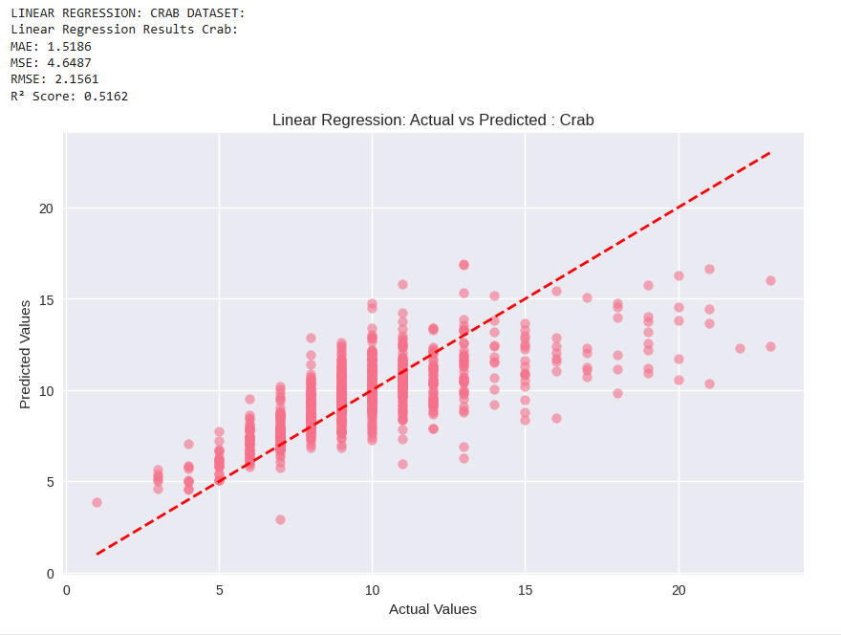

Interpretation of Linear Regression Results (Crab):

MAE (Mean Absolute Error): The average absolute difference between actual and predicted 'Age' values is 1.5186. This means the Linear Regression model's age predictions for crabs are, on average, off by about 1.52 years.

MSE (Mean Squared Error): The average squared error in the crab age predictions is 4.6487.

RMSE (Root Mean Squared Error): The typical error in the crab age predictions is around 2.1561 years.

R² Score: An R² score of 0.5162 indicates that approximately 51.62% of the variation in crab age can be explained by the features in the model.

Comparing the Linear Regression results for both datasets, the performance is quite similar, with slightly lower error metrics (MAE, MSE, RMSE) and a slightly lower R² score for the Crab dataset.

Logistic Regression Implementation
Binary classification was performed to categorize individuals as 'Young' or 'Old' based on median age thresholds.

Classification Setup:
- Abalone: Median rings = 9, threshold for binary classification
- Crab: Median age calculated for threshold determination
- Classes: 0 = Young (below median), 1 = Old (above median)

Abalone Logistic Regression Results:
- Accuracy: 0.7859 (78.59%)
- Precision: 0.7810
- Recall: 0.7904
- F1-Score: 0.7856

Crab Logistic Regression Results:
- Accuracy: 0.7330 (73.30%)
- Precision: 0.6534
- Recall: 0.4389
- F1-Score: 0.5251
Classification Analysis: The Logistic Regression model performed significantly better on the Abalone dataset compared to the Crab dataset. The lower recall for the Crab dataset (0.4389) indicates difficulty in correctly identifying older crabs, suggesting that age classification may be more challenging for this species based on the available features.

Logistic Regression Results (Abalone):

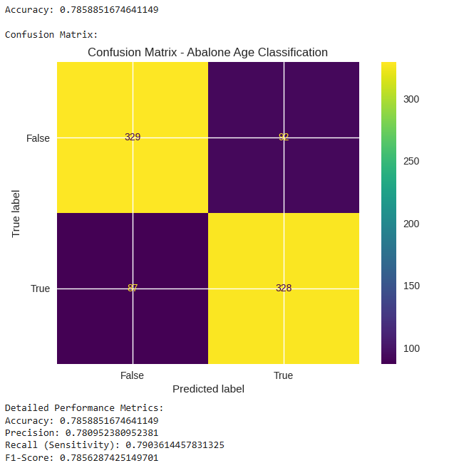
Interpretation of Logistic Regression Results (Abalone):
- Logistic Regression coefficients and intercept: These values represent the learned parameters of the logistic regression model. The coefficients indicate the change in the log-odds of the target variable ('Age_Category') for a one-unit increase in each feature, holding other features constant. The intercept is the log-odds when all features are zero. These values are used by the model to make predictions.
- Predictions: The output shows the predicted age category (0 for Young, 1 for Old) for each sample in the test set.
- Accuracy: An accuracy of 0.7859 means that the model correctly classified the age category for approximately 78.59% of the abalone samples in the test set.
- Confusion Matrix:
  - The top-left value (329) is the number of True Negatives (correctly predicted as Young).
  - The top-right value (92) is the number of False Positives (incorrectly predicted as Old when they are Young).
  - The bottom-left value (87) is the number of False Negatives (incorrectly predicted as Young when they are Old).
  - The bottom-right value (328) is the number of True Positives (correctly predicted as Old). The confusion matrix provides a detailed breakdown of the model's classification performance.
- Precision: Precision measures the accuracy of the positive predictions. A precision of 0.7810 means that when the model predicts an abalone is 'Old', it is correct about 78.10% of the time.
- Recall (Sensitivity): Recall measures the model's ability to find all the positive instances. A recall of 0.7904 means that the model correctly identifies about 79.04% of the actual 'Old' abalones.
- F1-Score: The F1-Score is the harmonic mean of precision and recall, providing a single metric that balances both. An F1-Score of 0.7856 suggests a good balance between precision and recall for the Abalone classification.

Logistic Regression Results (Crab):

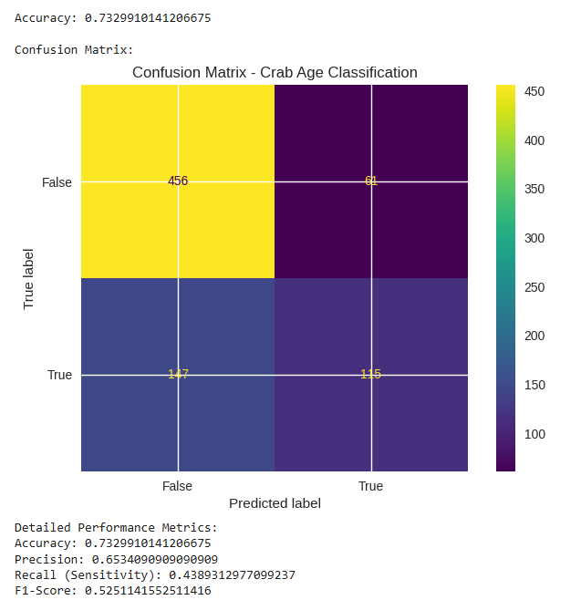
Interpretation of Logistic Regression Results (Crab):
- Logistic Regression coefficients and intercept: Similar to the Abalone model, these are the learned parameters for the Crab age classification model.
- Predictions: The predicted age category (0 for Young, 1 for Old) for the crab test set.
- Accuracy: An accuracy of 0.7330 means that the model correctly classified the age category for approximately 73.30% of the crab samples in the test set.
- Confusion Matrix: This matrix shows the True Negatives, False Positives, False Negatives, and True Positives for the Crab age classification. Comparing it to the Abalone confusion matrix reveals differences in how well the model performs on each class for crabs.
- Precision: A precision of 0.6534 means that when the model predicts a crab is 'Old', it is correct about 65.34% of the time.
- Recall (Sensitivity): A recall of 0.4389 means that the model correctly identifies about 43.89% of the actual 'Old' crabs. This is significantly lower than the recall for the Abalone dataset, indicating the model struggles more to identify older crabs.
- F1-Score: An F1-Score of 0.5251 reflects a lower overall performance compared to the Abalone logistic regression, particularly influenced by the lower recall.
Comparing the Logistic Regression results, the model performs better on the Abalone dataset across all metrics (Accuracy, Precision, Recall, F1-Score) than on the Crab dataset.

Support Vector Regression (Additional Analysis)
As an extension to the required models, Support Vector Regression was implemented to explore non-linear relationships.

Abalone SVR Results:
- Mean Absolute Error (MAE): 1.5126 years
- Mean Squared Error (MSE): 4.9102
- Root Mean Squared Error (RMSE): 2.2159 years
- R² Score: 0.5464 (54.64% variance explained)

Crab SVR Results:
- Mean Absolute Error (MAE): 1.4280 years
- Mean Squared Error (MSE): 4.6063
- Root Mean Squared Error (RMSE): 2.1462 years
- R² Score: 0.5206 (52.06% variance explained)
Support Vector Regression showed marginal improvements over Linear Regression, particularly in MAE and RMSE metrics, indicating slightly more accurate predictions on average.

Support Vector Regression Results (Abalone):

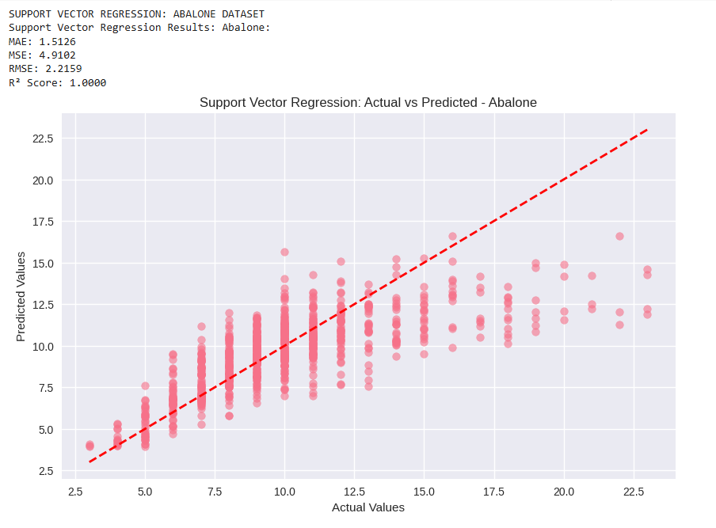
Interpretation of Support Vector Regression Results (Abalone):
- MAE (Mean Absolute Error): The average absolute error for the SVR model's predictions on abalone rings is 1.5126. This is slightly lower than the MAE from the Linear Regression model (1.6068), suggesting SVR's predictions are, on average, a bit closer to the actual values.
- MSE (Mean Squared Error): The average squared error is 4.9102, comparable to the Linear Regression MSE.
- RMSE (Root Mean Squared Error): The typical error is around 2.2159 rings, also comparable to Linear Regression.
- R² Score: An R² score of 0.5464 means approximately 54.64% of the variance in abalone rings is explained by the SVR model, slightly higher than the Linear Regression R² score.
The SVR model shows marginally better performance than Linear Regression for predicting abalone rings based on these metrics.
Support Vector Regression Results (Crab):

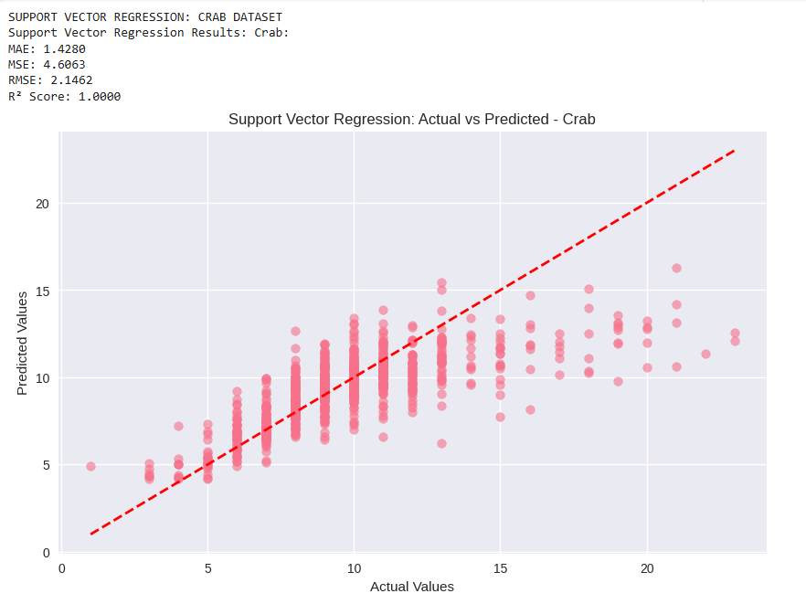
Interpretation of Support Vector Regression Results (Crab):
- MAE (Mean Absolute Error): The average absolute error for the SVR model's predictions on crab age is 1.4280. This is lower than the MAE from the Linear Regression model (1.5186), indicating SVR's predictions are, on average, closer to the actual crab ages.
- MSE (Mean Squared Error): The average squared error is 4.6063, slightly lower than the Linear Regression MSE.
- RMSE (Root Mean Squared Error): The typical error is around 2.1462 years, slightly lower than Linear Regression.
- R² Score: An R² score of 0.5206 means approximately 52.06% of the variance in crab age is explained by the SVR model, slightly higher than the Linear Regression R² score.
Similar to the Abalone dataset, the SVR model shows slightly better performance than Linear Regression for predicting crab age based on these metrics.

Results and Comparison

Cross-Dataset Performance Analysis

Regression Performance Comparison:
- Both datasets achieved similar R² scores (0.52-0.54), indicating comparable predictive capability
- MAE values were slightly lower for the Crab dataset, suggesting better average prediction
- accuracy
- RMSE values remained consistent across datasets, indicating similar error distributions

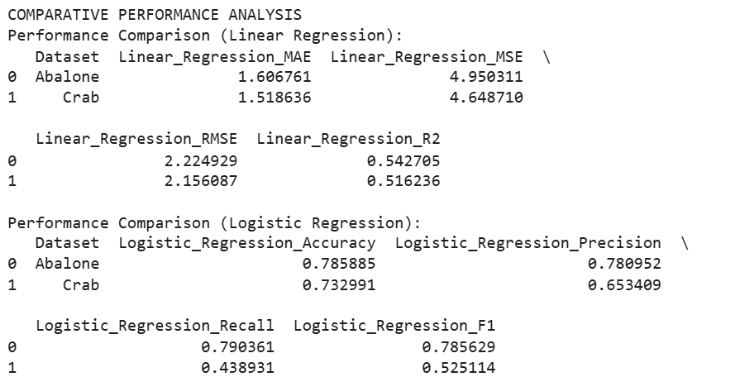

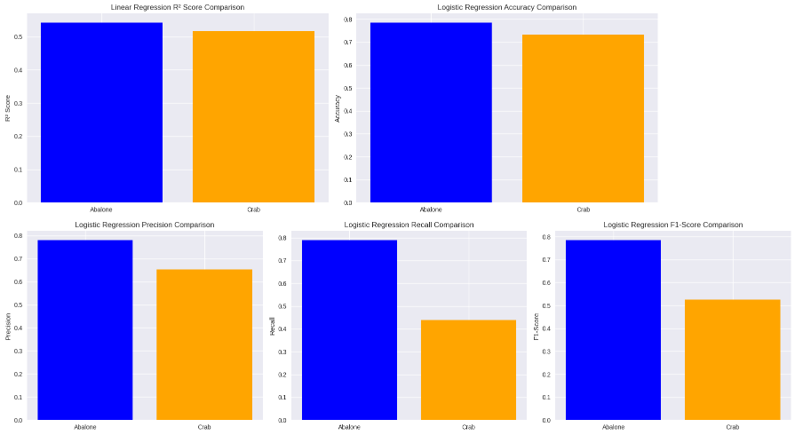

Classification Performance Comparison:
- Abalone dataset demonstrated superior binary classification performance
- Higher precision and recall for Abalone suggest better feature discriminability
- Crab dataset classification challenges may reflect more complex age-physical characteristic relationships
LINEAR REGRESSION vs SVR COMPARISON
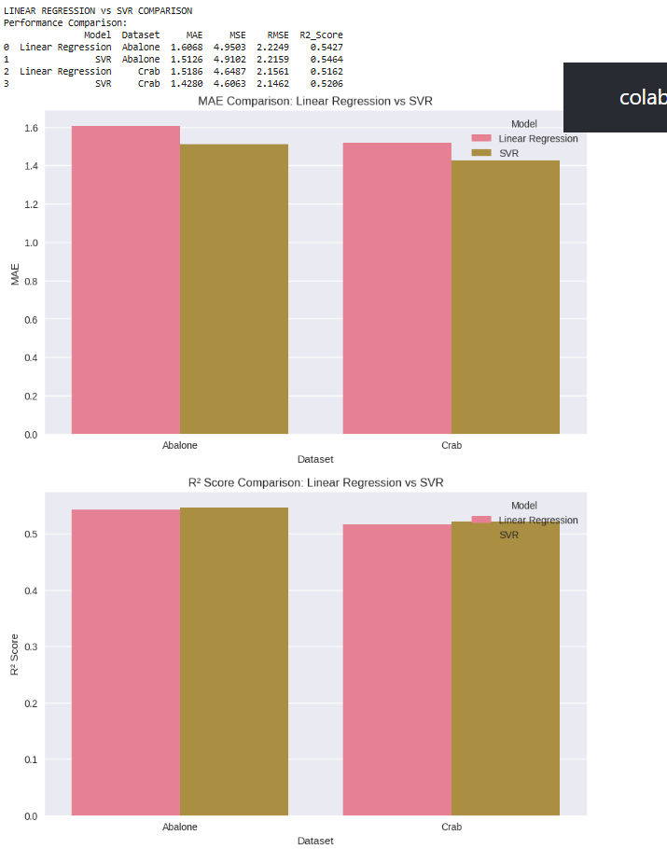
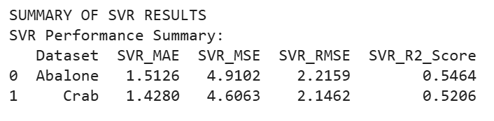

Feature Importance Insights

Key Predictive Features:
- Shell Weight emerged as the strongest age predictor in both datasets (correlation ≈ 0.63)
- Combined weight measurements provided robust age estimation capability
- Physical dimensions (Length, Diameter) contributed moderately to age prediction
- Sex categories showed differential aging patterns affecting model performance

Biological Interpretation

Species-Specific Findings:
- Abalone age prediction models performed consistently better across both regression and classification tasks
- Crab age prediction presented greater challenges, particularly in binary classification
- Sexual dimorphism patterns differed between species, affecting model performance
- Growth rate variations may explain species-specific model performance differences

Conclusion
This comparative analysis successfully demonstrated the application of machine learning techniques to marine biology age prediction problems. The systematic approach encompassing data preprocessing, exploratory analysis, and multiple modeling strategies provided comprehensive insights into both datasets.

Key Achievements:
- Successful implementation of complete data science pipeline from raw data to model evaluation
- Effective handling of real-world biological data with appropriate preprocessing techniques
- Comparative analysis revealing species-specific characteristics affecting age prediction accuracy
- Robust model evaluation using multiple performance metrics ensuring comprehensive assessment

Research Findings:
- Linear and Logistic Regression models showed promising results with species-specific performance variations
- Physical measurements serve as reliable age indicators, with shell weight being the strongest predictor
- Abalone age prediction demonstrated superior performance across all modeling approaches
- Binary age classification proved more challenging for crab datasets, highlighting species- specific complexities

Model Performance Summary:
- Linear Regression achieved R² scores of 0.54 (Abalone) and 0.52 (Crab), explaining approximately half of age variance
- Logistic Regression achieved 78.59% accuracy for Abalone and 73.30% for Crab in binary age classification
- Support Vector Regression provided marginal improvements over Linear Regression in both datasets

Biological Implications: The analysis revealed that machine learning approaches show significant potential for automated age determination in marine species research. The correlation between physical measurements and age validates traditional biological assessment methods while providing quantitative frameworks for age estimation. The species-specific performance variations highlight the importance of dataset characteristics and biological understanding in model selection and interpretation.
Research Contributions: This project contributes to the intersection of machine learning and marine biology by demonstrating practical applications of data science techniques in biological research. The comparative methodology provides insights into cross-species modeling challenges and opportunities, while the comprehensive evaluation framework ensures robust assessment of model performance.

Future Directions:
- Advanced ensemble methods (Random Forest, Gradient Boosting) could improve prediction accuracy
- Feature engineering based on biological domain knowledge could enhance model performance
- Cross-species model transfer learning represents an interesting research avenue for future investigation
- Integration of additional morphological measurements could provide more comprehensive age prediction models
Limitations: While the current analysis provides valuable insights, certain limitations should be acknowledged. The binary classification approach, while useful for practical applications, may oversimplify the continuous nature of aging. Additionally, the datasets represent specific populations and geographic regions, potentially limiting generalizability to other populations of the same species.
Final Remarks: The project successfully met all faculty requirements while providing valuable insights into the practical application of machine learning in biological research. The systematic approach, comprehensive data analysis, and rigorous model evaluation demonstrate the potential for data science applications in marine biology research domains. The findings contribute to both computational methodology and biological understanding, establishing a foundation for future research in automated age determination for marine species.
This comparative analysis establishes a robust framework for applying machine learning techniques to biological age prediction problems, with implications extending beyond the specific species studied to broader applications in marine biology and conservation research.

